**Objective Questions**:

1. What is the total no. of tables present in the data?

Ans: 2

1. What is the total no. of attributes present in the data?

Ans: 22

1. How many categorical columns are there in the data? [Search about categorical and continuous data, and try to answer this question]

Ans: 14

1. The data consists of some inconsistent and missing values so ensure that the data used for further analysis is cleaned.

Ans: There are missing values in cuisine column where country is America.

These blank cells are imputed with American cuisine which is most common

USA.

1. Using the LookUp functions, fill up the countries in the original data using the country code.

Ans:

|  |
| --- |
| **Country** |
| India |
| India |
| India |
| India |

Formula: =XLOOKUP(C2,'country & dollar value'!A:A,'country & dollar value'!B:B)

1. Create a table to represent the number of restaurants opened in each country.

**Ans:**

|  |  |
| --- | --- |
| **Country** | **Number of Restaurants** |
| Australia | 24 |
| Brazil | 60 |
| Canada | 4 |
| India | 8652 |
| Indonesia | 21 |
| New Zealand | 40 |
| Philippines | 22 |
| Qatar | 20 |
| Singapore | 20 |
| South Africa | 60 |
| Sri Lanka | 20 |
| Turkey | 34 |
| United Arab Emirates | 60 |
| United Kingdom | 80 |
| United States of America | 434 |
| **Grand Total** | **9551** |

1. Also, the management wants to look at the number of restaurants opened each year, so provide them with something here.

Ans:

|  |  |
| --- | --- |
| **Year** | **Number of Restaurants** |
| 2010 | 1080 |
| 2011 | 1098 |
| 2012 | 1022 |
| 2013 | 1061 |
| 2014 | 1051 |
| 2015 | 1024 |
| 2016 | 1027 |
| 2017 | 1086 |
| 2018 | 1102 |
| **Grand Total** | **9551** |

1. What is the total number of restaurants in India in the price range of 4?

Ans:



1. What is the average number of voters for the restaurants in each country according to the data?

Ans:

|  |  |
| --- | --- |
| **Country & Restaurants** | **Average of Votes** |
| **Australia** | **111** |
| **Brazil** | **20** |
| **Canada** | **103** |
| **India** | **137** |
| **Indonesia** | **772** |
| **New Zealand** | **243** |
| **Philippines** | **407** |
| **Qatar** | **164** |
| **Singapore** | **32** |
| **South Africa** | **315** |
| **Sri Lanka** | **146** |
| **Turkey** | **431** |
| **United Arab Emirates** | **494** |
| **United Kingdom** | **205** |
| **United States of America** | **428** |
| **Grand Total** | **157** |

1. Calculate the average rating for all the restaurants that have price_range < 4 and provide online delivery. Use only the “IF” function, Logical Operators, and Aggregation functions to solve this problem. **[Note: Don’t use Conditional aggregation in this question.]**

Ans:

Formula : AVERAGE(IF((Table2[Price_range] < 4)*(Table2[Has_Online_delivery]="Yes"),Table2[Rating]))

Result: 3.27

1. Using Conditional formatting highlight the rows of restaurants that are located in the countries or cities that you’ve suggested to the management for opening new restaurants.

Ans: Reference – Used Data sheet of Excel file

1. Create a new customized price column that consists of the abbreviation/symbol of the currency along with the Average_cost_for_two value. [Use string operations to do this task]

Ans:

|  |
| --- |
| **Average_Cost_for_two2** |
| ₹300 |

1. How can you create an array formula in Excel or Google Sheets to count the number of restaurants listed that do not offer online delivery, are in the lowest price range, and have an average cost for two people less than or equal to 250 Indian Rupees?

Ans:

Formula : =COUNTIFS(Table2[Has_Online_delivery],"No",Table2[Price_range], MIN(Table2[Price_range]),Table2[Average_Cost_for_two],"<=250")

**Result :** 1834

**Subjective Questions**:

1. Suggest a few countries where the team can open newer restaurants with lesser competition. Which visualization/technique will you use here to justify the suggestions?

**Ans:**

* A number of restaurants per country

  Description automatically generatedFrom the chart it is clearly visible that India & USA have the greatest number of restaurants.
* A higher number of restaurants will create more competition resulting in a heavily cluttered market. So, I have excluded India & USA.

* United Arab Emirates is a country where Online delivery is already available.
* Opening new restaurants in UAE means facing competition from existing players. Therefore, we can exclude UAE also

* From the chart it is clearly visible that Turkey & Sri Lanka has the lowest cost for 2 in rupees.
* Because of the exceptionally low cost, achieving break-even might pose a challenge. So, Turkey & Sri Lanka has been excluded.
* 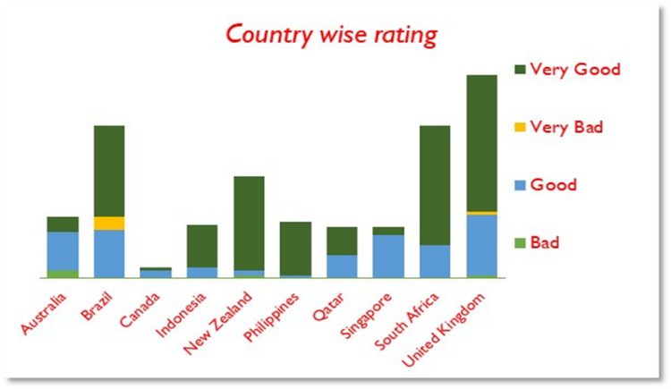Brazil & United Kingdom are two countries where people have given Very Bad rating.
* Because of this we can consider people in these two countries are not so restaurant friendly.
* Therefore, we can exclude Brazil & United Kingdom.
* 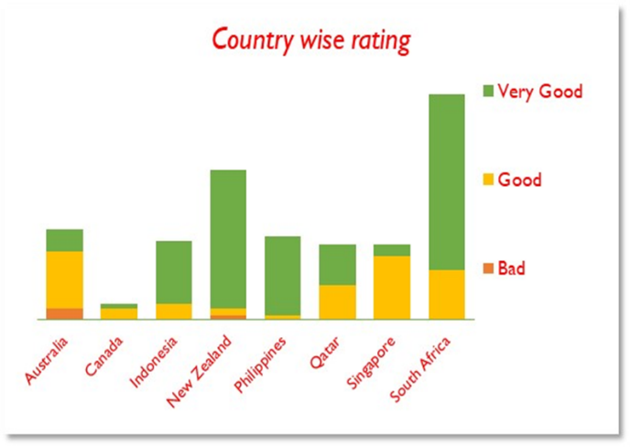 From the chart it is clearly visible that Australia, Canada, Singapore are three countries where number of restaurants with very good rating is extremely low. Rest all the countries have high number of restaurants with very good ratings that creates a highly cluttered market.
* So, we will exclude rest all the countries

**From this insight we can consider that Australia, Canada & Singapore are three countries where there is demand for restaurants with very good rating.**

1. A yellow and red table with black text

   Description automatically generatedCome up with the names of States and cities in the suggested countries suitable for opening restaurants.

Ans:

* Cities in green colour have ratings of more than 4. If we open restaurants in these cities, we will face tough competition from existing restaurants of these cities.
* Cities in red colour have a rating of less than 3.5. From this we can assume that these cities are not so restaurant friendly.
* Cities in yellow colour have a rating of greater than 3.5 but less than 4. From this we can consider that these cities have scope of opening new restaurants.
* We will do more analysis on cities in yellow colour range.
* A graph with numbers and text

  Description automatically generatedFrom the chart it is clearly visible that Singapore, Middleton Beach & Chatham-Kent are 3 cities where cost for 2 in rupees is maximum.
* Because of the exceptionally low cost, achieving break-even might pose a challenge.
* So, we will select top 3 cities Singapore, Middleton Beach & Chatham-Kent.

After doing extensive analysis I will suggest below 3 cities for opening new restaurants.

* 1. Singapore
  2. Middleton Beach
  3. Chatham-Kent

1. According to the countries you suggested, what is the current quality regarding ratings for restaurants that are open there?

Ans:

**Rating Quality in Australia**

* 26% restaurants have a rating of more than 4
* 52% restaurants have a rating between 3.5 & 4
* 22% restaurants have a rating less than 3.5

**Therefore, we can say that most restaurants fall in the mid category of 3.5 & 4.**

**Least number of restaurants falls in the bad category of less than 3.5.**



**Rating Quality in Canada**

* **25% restaurants have a rating of more than 4**
* **25% restaurants have a rating between 3.5 & 4**
* **50% restaurants have a rating of less than 3.5**

**Most restaurants fall in the bad category of less than 3.5**

**Rating Quality in Singapore**

* **All the restaurants have an average rating between 3.5 & 4**

**All the restaurants fall in mid category of 3.5 & 4**

1. Also, what is the current expenditure on food in the suggested countries, so we can keep our financial expenditure in control?

Ans:

* In Singapore expenditure is highest among suggested countries.
* In Canada expenditure is comparatively lower.
* In Australia expenditure is least among suggested countries.
* Overall expenditure on food is on higher side in suggested countries.
  1. Creativity & Innovation: High expenditure on food encourages chefs to experiment with unique flavours, presentation, and culinary techniques. Creative dishes can become signature items that draw customers specifically to your restaurant.
  2. Menu Variety: A larger food budget allows you to offer a diverse menu with a wider range of dishes. Variety attracts different customer preferences and dietary needs, ensuring that there’s something for everyone.
  3. Quality & Reputation: Spending on high-quality ingredients can enhance the taste and overall dining experience for customers. Word-of-mouth recommendations and online reviews often highlight exceptional food quality.
  4. Customer Satisfaction: For prioritizing food quality customers are more likely to leave satisfied and return for future visits. Repeat business is crucial for long-term success.

1. Come up with the names of restaurants from the recommended states that are our biggest competitors and also those that are rated in the lower brackets, i.e. 1-2 or 2-3.

Ans: Singapore City

Al'frank Cookies, Fratini La Trattoria, Cut by Wolfgang Puck are 3 restaurants that ar our biggest competitors.

Potato Head Folk, The Lokal, Makansutra Gluttons Bay are 3 restaurants that are rated in lower brackets

 Chatham-Kent City

Tokyo Sushi is our biggest competitor.

 Middleton Beach City

Three Anchors is our biggest competitor.

1. Which cuisines should we focus on in the newer restaurants to get better feedback? Does the choice of cuisines affect the restaurant ratings?

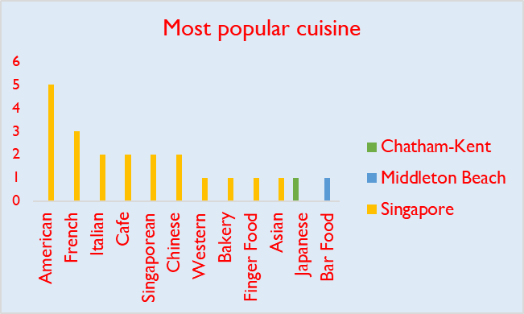Ans: Singapore

In Singapore top 3 common cuisines are American, French, Italian

Chatham-Kent City

In Chatham-Kent City most common cuisine is Japanese.

Middleton Beach City

In Middleton Beach City most common cuisine is Bar Food.

My recommendation for cuisine

* Singapore: American & French
* Middleton Beach : Bar Food
* Chatham-Kent : Japanese

In my analysis did not find a strong relation between cuisine & rating. I have found that most common cuisine does not have a high rating in most cases & local cuisines some places got a high rating but there are many cases where local cuisines got low rating also. Correlation between number of restaurants & average rating is -0.24.

While doing regression analysis I have found that value of R Square is 0.57 which is not very close to 0.

Reference : Cuisine vs Rating sheet of excel file.

Considering the above mentioned insights I can say that there is not a very strong correlation between choice of cuisine & rating.

1. According to our current data, should we go for online delivery and table booking? Does that affect the customer’s ratings?

Ans:

From the pivot table it is clearly visible that with online delivery higher rating has been achieved.



From the pivot table it is clearly visible that with table booking rating has been increased.

Therefore, my suggestion will go for online delivery & table booking. Yes, online delivery & table booking affects rating. It increases rating.

1. Should the team keep the rate of cuisines higher? Will that affect the feedback? According to our data are the rates of cuisines and ratings, correlated?

Ans:

Correlation between price of cuisines & rating is 0.33. During regression analysis I found the value of R square matric is 0.10

Reference: Price vs Rating sheet of excel file.

Team should not keep the rate of cuisines higher. Higher rate does not affect feedback significantly. Rates of cuisines & rating is not strongly correlated.

1. What is the distribution of the number of restaurants of different price ranges in all the countries?

Ans:

I converted average cost in Indian Rupees. Then I created 4 buckets of ₹0 to ₹300, ₹300 to ₹600, ₹600 to ₹1000 & >₹1000. The I created a pivot keeping price range in row column & count of restaurants in value column.

Most number of restaurants fall under ₹300 to ₹600 bucket whereas least number of restaurants fall under ₹600 to ₹1000 bucket.

1. Explain your approach in brief for suggesting countries/cities in order to open new restaurants

Ans:

* 1. **Exclude** **India & USA as these two countries have high number of restaurants already available.**
  2. **United Arab Emirates is a country where Online delivery is already available.**

**Opening new restaurants in UAE means facing competition from existing players.**

**Therefore, we can exclude UAE also**

* 1. **Turkey & Sri Lanka has the lowest cost for 2 in dollar. Because of the exceptionally low cost, achieving break-even might pose a challenge.**

**So, we will exclude Turkey & Sri Lanka.**

* 1. **Brazil & United Kingdom are two countries where people have given Very Bad rating.** **Because of this we can consider people in these two countries are not so restaurant friendly. Therefore, we can exclude Brazil & United Kingdom.**
  2. **Australia, Canada, Singapore are three countries where number of restaurants with very good rating is extremely low. Rest all the countries have high number of restaurants with very good ratings that creates a highly cluttered market.** **From this insight we can consider that Australia, Canada & Singapore are three countries where there is demand for restaurants with very good rating. So, we will exclude Turkey & Sri Lanka.**
  3. **Countries that I will recommend are Canada, Australia, Singapore**
  4. **If we open restaurants in cities having ratings of 4 or more than 4, we must face tough competition from existing restaurants of these cities. For cities having a rating of less than 3.5 we can assume that these cities are not so restaurant friendly. For cities having a rating of greater than 3.5 but less than 4 we can consider that these cities have the scope of opening new restaurants.**
  5. **High expenditure on food encourages chefs to experiment with unique flavours, presentation, and culinary techniques. Creative dishes can become signature items that draw customers specifically to your restaurant. A larger food budget allows you to offer a diverse menu with a wider range of dishes. Variety attracts different customer preferences and dietary needs, ensuring that there’s something for everyone.**
  6. **Spending on high-quality ingredients can enhance the taste and overall dining experience for customers. Word-of-mouth recommendations and online reviews often highlight exceptional food quality.**

**For prioritizing food quality customers are more likely to leave satisfied and return for future visits. Repeat business is crucial for long-term success.**

* 1. **Providing online delivery & table booking facility will increase customer rating significantly.**